|  |  |  |
| --- | --- | --- |
|  |  | Instructions to install and use  Google Sheet Into DB(Django) |

June 2, 2016 Yiwei Sun

Table of Contents

Installation 2

Python 2.7 2

Postgresql 3

Pip 3

Virtual environment 3

Django and other packages with pip in virtual environment 3

usage 5

Reference: 11

# 

# Installation

Before use the program, you have to install couple of software packages including virtual environment. The following installations are all in a terminal window.



## Python 2.7

From <https://www.python.org/downloads/mac-osx/> download the Max OS X 64-bit/32-bit installer.

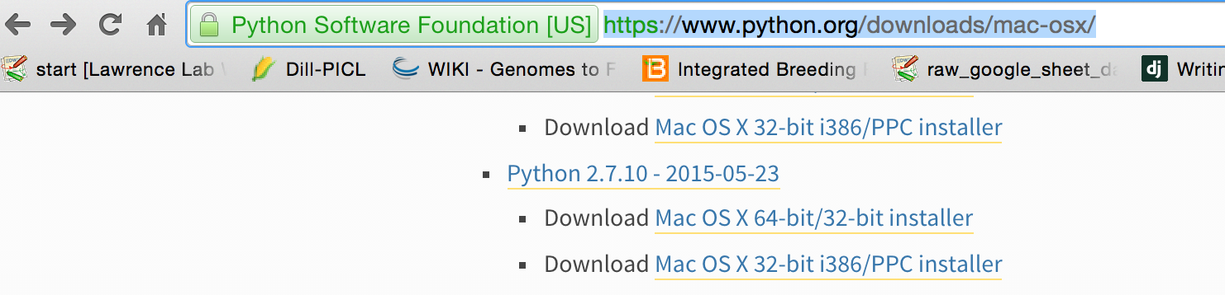

## Postgresql

Download it from https://www.postgresql.org/download/macosx/

## Pip

sudo easy_install pip

## Virtual environment

sudo easy_install pip

sudo –H pip install virtualenv

virtualenv –-version # to check if the virtualenv is installed correctly

virtualenv <Dir> # For example, virtualenv virtual_env/venv

source <Dir>/bin/activate   
# For instance, source virtual_env/venv/bin/activate

## Django and other packages with pip in virtual environment

Go to home dir:

(venv) D25QC0NMFY13:venv yiweisun$ cd ~

(venv) D25QC0NMFY13:~ yiweisun$

pip install django # Django 1.9 is tested.

pip install gspread

pip install gdata

* pip install psycopg2 #It needs to preinstall Postgresql

If you have the following Error:

Error: pg_config executable not found.

$ cd ~

$ nano .bash_profile

Add this if you use version 9.4 in the .bash_profile:

export PATH=$PATH:/Applications/Postgres.app/Contents/Versions/9.4/bin

After save the file, run the following, note that there is a space between two dots.

$ . .bash_profile

Check if it is installed correctly:

$ which pg_config

/Applications/Postgres.app/Contents/Versions/9.4/bin/pg_config

Then pip install psycopg2:

$ pip install psycopg2

<http://cheng.logdown.com/posts/2015/01/17/install-postgresql-and-psycopg2-on-mac-osx>

* pip install --upgrade oauth2client
* pip install django-sheets

Then either download or Git clone the whole directory mysite into your destination, for example, Documents/workspace/

After that, make sure that two apps in mysite/mysite/settings.py:

INSTALLED_APPS = (

...

**'googleSheetIntoDB.apps.GooglesheetintodbConfig'**,  
**'sheets'**,

...

)

If you would like to manage the Django server with its web service, this command will help you:

Python manage.py createsuperuser

I have already create one: (user: admin password: administrator) which you can use to access the Django administration page in <http://127.0.0.1:8000/admin/>

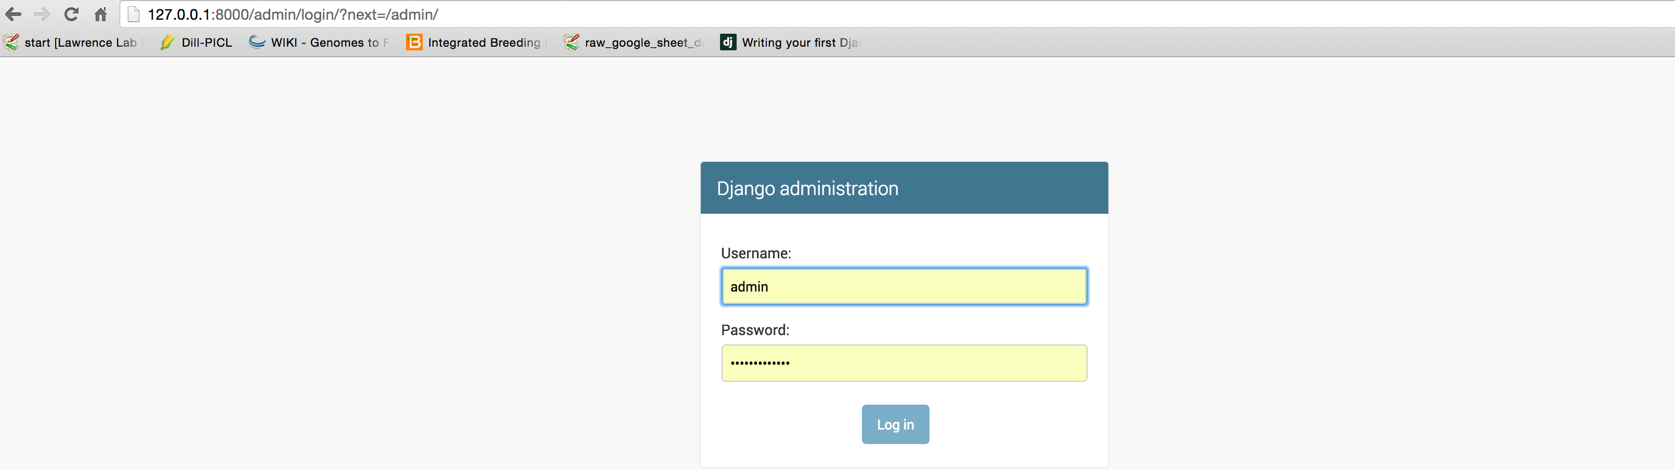

**Start server**

After the installation, under virtual environment, go to mysite/ which contains the manage.py, with the following command:

Python manage.py runserver

Then you should see something like this which means the server is ready:

June 02, 2016 - 20:43:40

Django version 1.9.6, using settings 'mysite.settings'

Starting development server at http://127.0.0.1:8000/

Quit the server with CONTROL-C.

# usage

**Google sheet Credential**

Make sure that you have a gmail account, then go to <https://console.developers.google.com> to create a project:

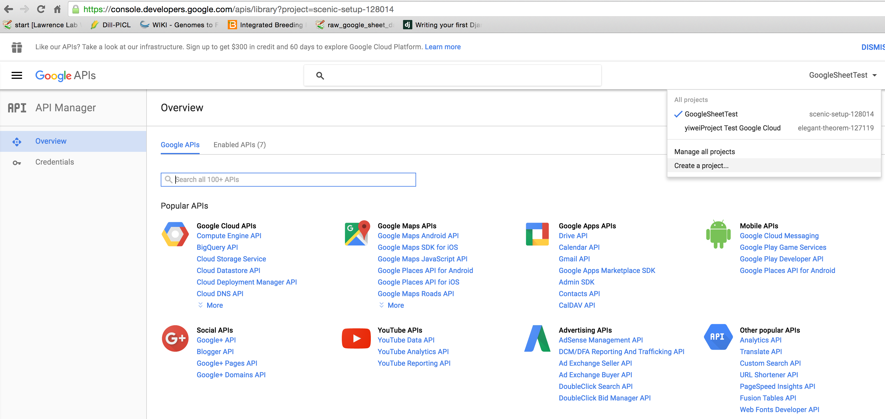

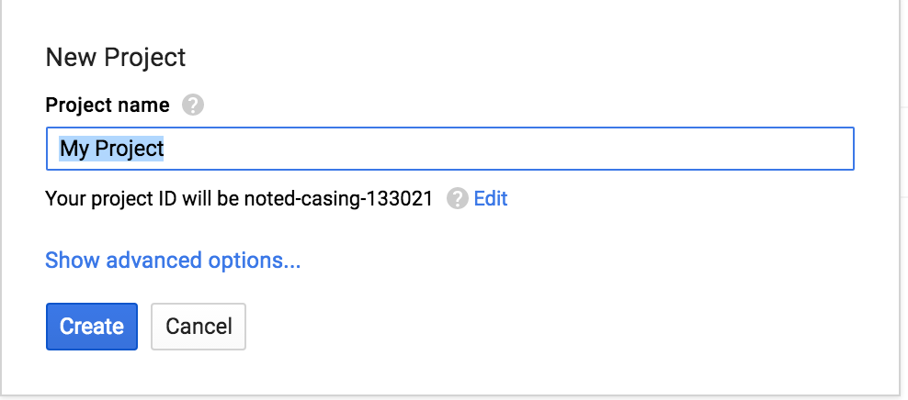

Next, go to credentials/Create credentials/Service account key

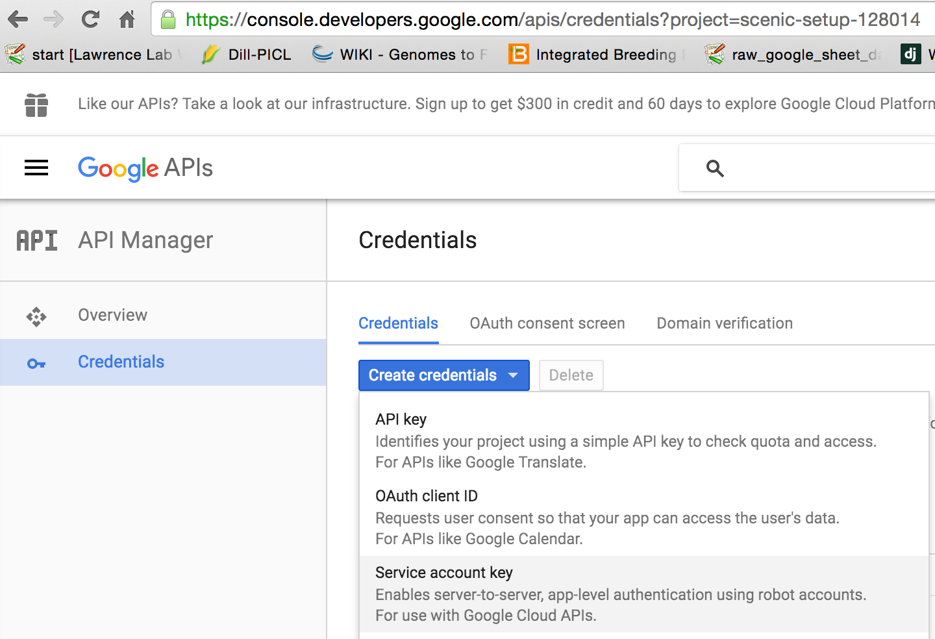

In the Service account, select App Engine default service account:

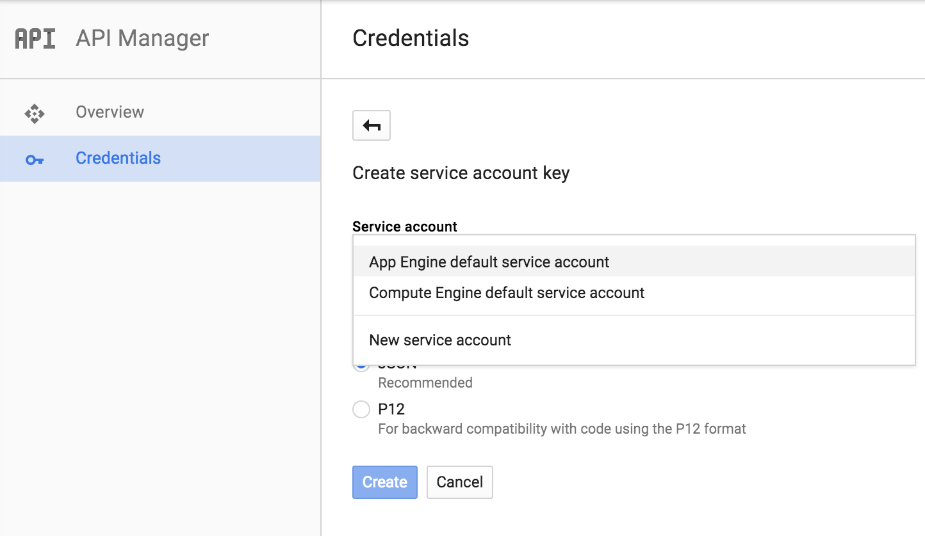

Select JSON:

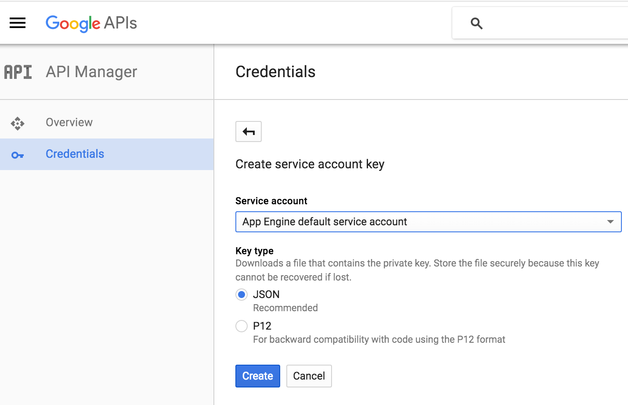

Click Create button to get a Google credential JSON file into your Download folder.

In the JSON file, find the client_email:

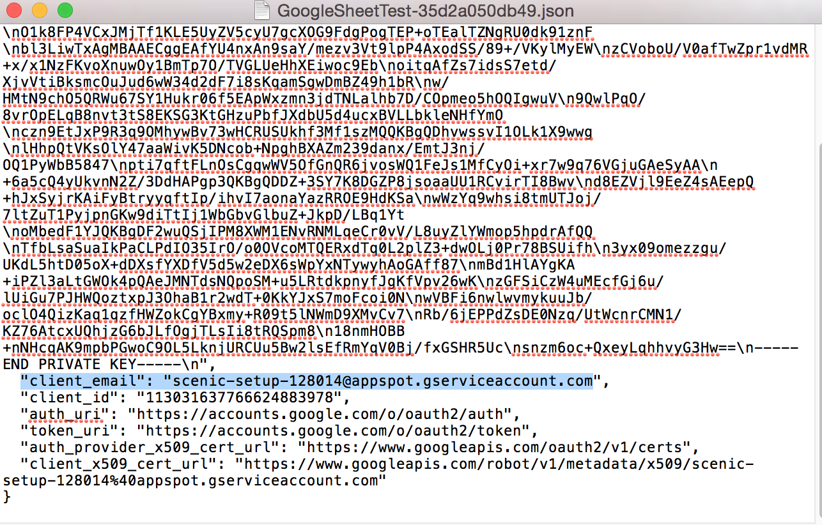

Copy that client_email address, go to every Google sheet to click the Share button on the top right corner:

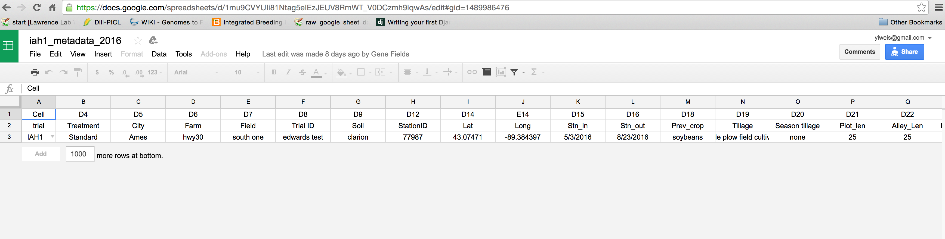

Under People, paste the client_email address into the text area:

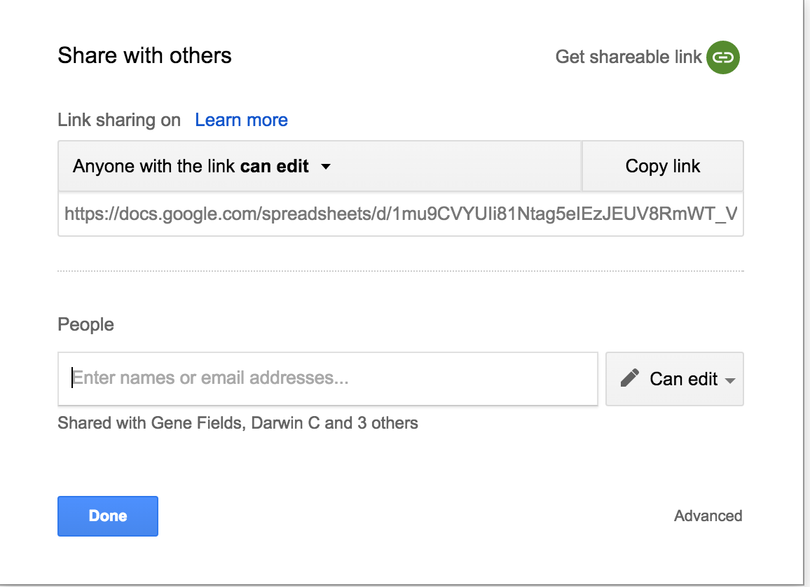

Then click “Done” button.

Repeat the “Share” operation with every Google sheet to let it share with the client_email address.

**Input JSON path and trial_year:**

* Copy the JSON file path that you downloaded, such as ‘/Users/yiweisun/Downloads/GoogleSheetTest-d112a30fe1a8.json’;
* In a browser address window, type in <http://127.0.0.1:8000/googleSheetIntoDB/>

Paste the JSON file path into json_path area, type in the trial year, such as 2016, then click “YES” button:

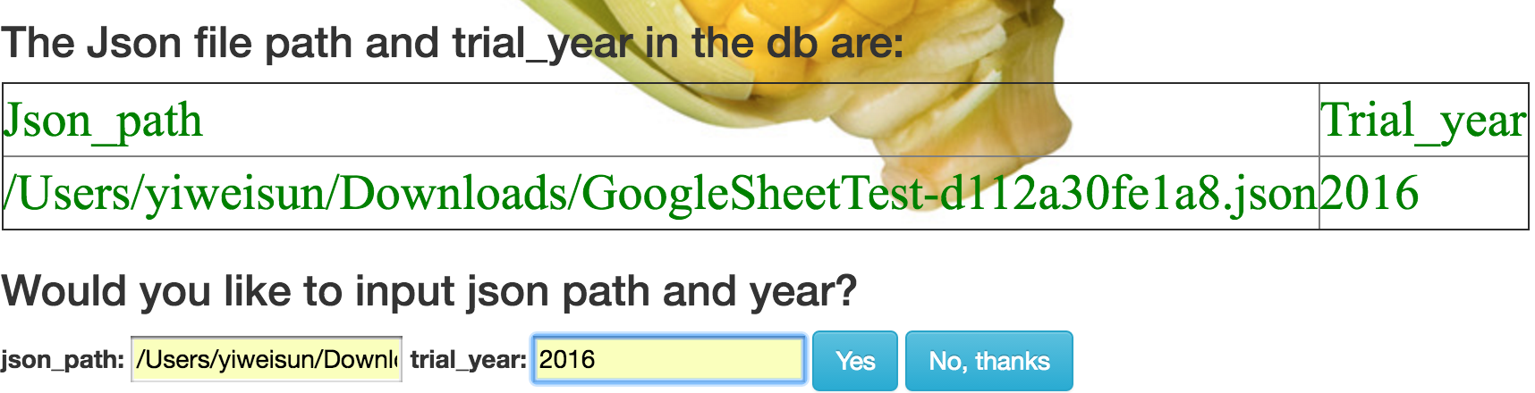

If the json path and trial year are already in the database, the system will show up red alerts and clear the text areas:

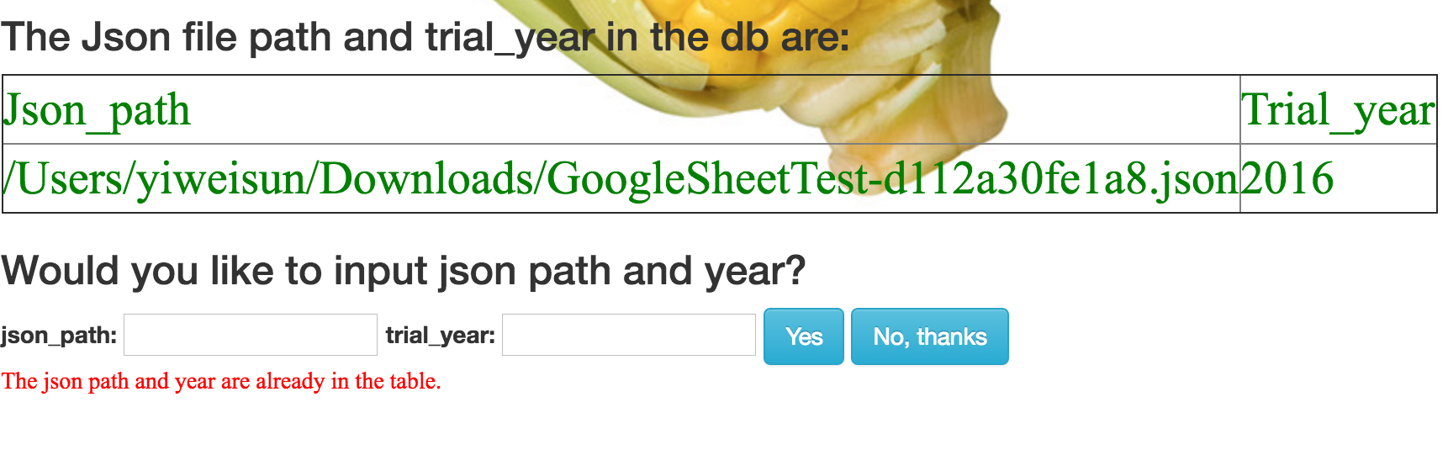Click “No, thanks” button, it will go to data_index.html:

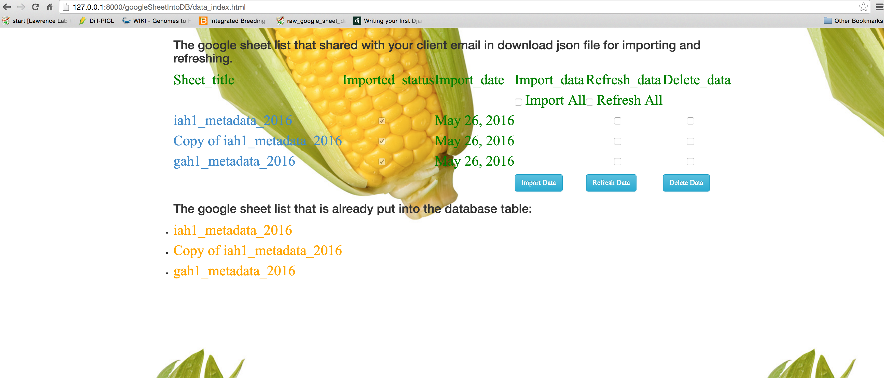

Then you can select either “Import Data”, “Refresh Data” or “Delete Data” button to click for your choice of action.

## Reference:

(Rajaraman, 2016)